10 Reasons to Hire a Veteran
Phil Quigley, talent acquisition professional and former Marine
Spoiler alert: They’re primed and ready for your toughest interview questions!
If you’re out to win the war for talent, you owe it to your organization, indeed to your country, to tap into some of our nation’s most unheralded resources-- military veterans. Aside from the obvious PR value which accrues to your company--not to mention the patriotic bragging rights--vets bring a locker box full of talents, strengths and problem solving skills to the job. Veterans are highly skilled, highly trained, and highly motivated. They’re goal oriented, results driven, organizationally savvy team players with the kind of practical know how and can do spirit that can solve your most pressing problems-- on time, within budget.
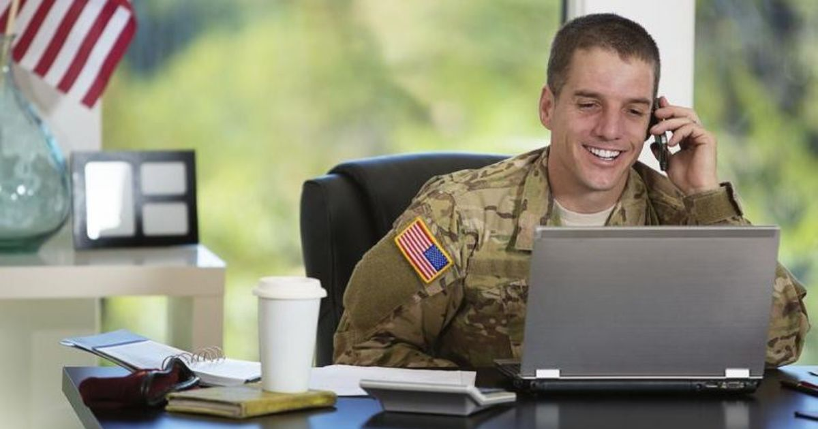
Reason #1: They’re quick learners
Rapid learning is embedded in their DNA—to maintain combat readiness, they had to master the tools of their trade at flank speed. Veterans train relentlessly, whether upgrading their skills in an F-18 flight simulator, trouble shooting AEGIS target tracking radar, or brushing up on urban warfare tactics. Businesses invest substantially in training, ramp-up time and information retention; vets deliver the kind of ROI that assures their employer a healthy competitive edge. Regardless of the military branch or rank, every veteran who holds an honorable discharge has gone through months — if not years – of intensive training to build new technical, organizational and interpersonal skills that transfer seamlessly to civilian jobs.

Reason #2: They’re goal oriented
“When the going gets tough, the tough get going” pretty much describes today’s veterans; you can count on them to achieve your most intractable, challenging and aggressive targets. They’re highly skilled at defining, executing and measuring goals…achieving the objective is always job #1 in the military. As an employer you want to invest in people who are likely to stick with a project through completion or commit long term to a team. Depend upon it---vets get the job done for you. Keep in mind, an honorable discharge in the military is similar to a four-year degree and demonstrates the ability to stay true, hang in there, and achieve both long and short term goals.

Reason #3: Vets are focused, disciplined and accountable
During their military service, veterans have learned to focus with laser like intensity on their mission…they operate with SWAT like precision, a high degree of discipline, and uncompromising personal accountability. They see the problem, own the problem, solve the problem, and implement the solution. Day in, day out they demonstrate positive self-control, strength of character and unequalled efficiency — all of which can benefit any business.

Reason #4: Vets are supportive team players
The old phrase, “There is no “i” in team…but there is in “win”, defines the cohesiveness and spirit d’ corps that characterize military units. From boot camp to the frontlines, from fire team to division, veterans work in teams. There is simply no such thing as a “lone ranger” in the military. Talk to any veteran about their experiences…they’ll share vivid examples of collective achievement that built both satisfaction and pride in their unit. Military veterans are trained to work together -- and rely on one another to get the job done. Vets have your back!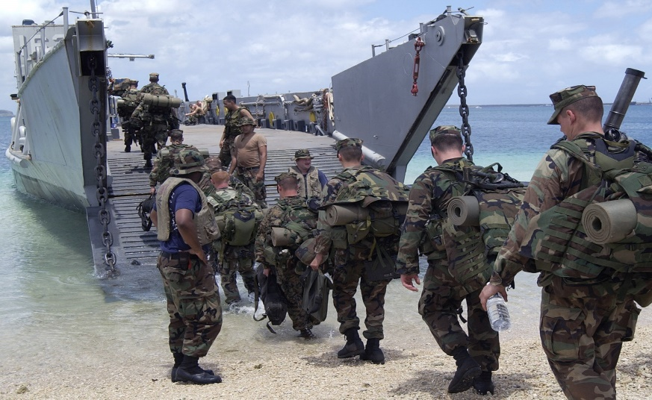

Reason #5: Vets are loyal…and dedicated to the organization
Loyalty among employees these day is fungible…people change jobs at near Mach 3 speed. Today’s workers are far more loyal to their profession than to their current employer. Human Resource studies reveal that millennials—folks in their twenties and early thirties—switch employers on average every 13 months. They have one eye on their office PC and the other on the latest hot job posting on LinkedIn. The churn is costly—projects and initiatives get delayed, hiring and training expenses soar, and employee morale and engagement languishes.
Want to reduce turnover in your workplace? Hire military veterans. Just as they gave loyal, committed service to their unit, they’ll give it to your business. They’ve learned how to stick to a project or mission until completion---under exacting and fatiguing conditions that test their mettle to the max. This brand of loyalty is hard to come by---but you’ll find it in the veterans you welcome aboard.

Reason #6: Vets Bring a Strong Sense of Character
From Valley Forge to Fallujah, vets have quietly, competently and valiantly answered their country’s call to the colors. Their culture is built upon a set of character revealing core values that include courage, sacrifice and dedication to mission. These values have been tested in demanding, dangerous conditions, often in the crucible of combat. The phrase duty, honor, country means something to veterans…they’re touchstones that define their character. The Marines, for example, value honor, courage and commitment—the same set of core values you’d like to embed in your organization!

Reason #7: Vets are trustworthy and dependable
You can trust vets to get the job done. They’ve proudly and voluntarily served their nation, and they’ll bring the same brand of trust and dependability that characterized their service to your company. When vets commit to a mission, they perform it wholeheartedly. Failure is not an option---lives depend upon carrying it out effectively. Similarly, when they undertake a task for you as their new employer, they’ll deliver the kind of uncompromising results that inspires your team and propels your organization forward. Hire a vet and get a committed contributor!

Reason #8: Vets are proven problem solvers
Whether distributing food and water to earthquake victims in Nepal, building schools in Kandahar or Port Au Prince, or training Iraqi police recruits in Ramadi, veterans encounter a distinctive array of complex and multi-tiered problems. They learn to tackle extraordinary problems like these head on ---with scarce resources, tight deadlines, and little more than determination and ingenuity to see them through. They bring fresh perspectives and imaginative approaches to solving problems…and they’ll bring that same expertise to you as their new employer. 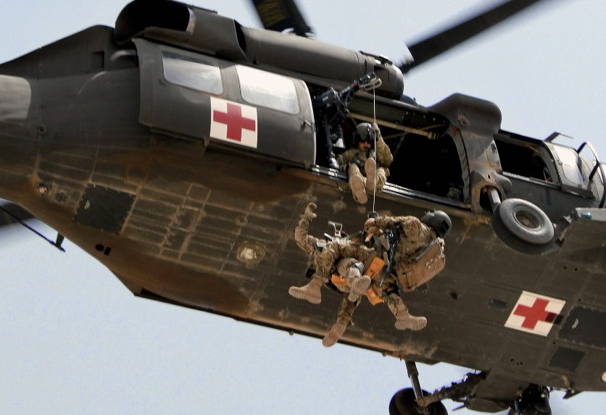

Reason #9: Vets perform under pressure
During the Battle of Britain, Spitfire pilots like Douglas Bader and Sailor Malan flew as many as 6 missions as day to swat down the Luftwaffe. Exhausted and stressed out, they took to the skies because they had no choice---to save their embattled country they performed flawlessly under extreme pressure. And in tribute to their unflinching courage, Winston Churchill said, “Never in the annals of human conflict have so many owed so much to so few”.
Today’s F-18 pilots launching from the USS Harry S. Truman and flying missions in Kurdistan know what Bader and Malan experienced.
Equally daunting are the pressures all our vets face today---multiple deployments, constant danger, disrupted families. Veterans are tested in ways that most civilians never are---mentally, physically and morally. Mental toughness, determination, grit – these are the qualities that see them through. The ability to stay cool and perform under pressure is a must in the military; in fact, their lives often depended upon it.
So when your organization is under pressure to win share from fierce competitors, call on employees with military experience…they’ll get it done for you!

Reason #10: Vets respect the chain of command
Military veterans respect the chain of command…and are trained to take charge when required. They understand how organizations function and know how to work effectively in structured situations. They bring order and discipline to chaotic conditions--think startups! While trained to follow procedures, they’re not shy about challenging those that impede progress. They’re precise communicators, skilled at building productive working relationships with folks at all levels of the hierarchy. As proven team players, they’ll fit seamlessly into your enterprise.
The Takeaway
Military veterans are known for precise communication, individual accountability, impeccable execution and natural leadership. All four skills are in high demand by organizations keen to stay sharp by hiring the best and the brightest. Vets are bullet proof investments—they’re highly motivated, with natural talents like poise, initiative, ingenuity, and the ability to handle stressful situations well.
So don’t be afraid to test their mettle with some tough, revealing behavioral interview questions! And by framing your questions with the PAR acronym – problem action, result—you’ll give them a chance to show exactly what they can do for you.
They’re ready to deliver for you the same unflinching service that they delivered to Uncle Sam. Want to create the kind of organization that people die to work for? Want to build a fired up, fully engaged workforce? Want to outflank your competitors? Hire a vet today!

‘Hiring veterans: It’s not just the right thing to do — it’s the right thing for business.’

— Jim O’Donnell, head of military and veteran recruiting, JPMorgan Chase & Co.

Hicks Professional Group Headquarters

28
DVBE partnerships

9

